A point in a geometry is a Vector in ml, for example for IRIS dataset a vector/point is a one row in whole dataset for all 5 features.

Vector is represented as a point in any dimension space, It’s written as: (let’s say for IRIS)

p = [ 1, 2.4, 0.6, 3, 0]

Here each value of p is known as component, and for our ex:

* X1 is SL
* X2 is SW
* X3 is PL
* X4 is PW
* X5 is class of setosa (for our ex 0 is setosa)

Similarly we have ‘n’ no of features then vector would be as:

P = [a1, a2………………, an]

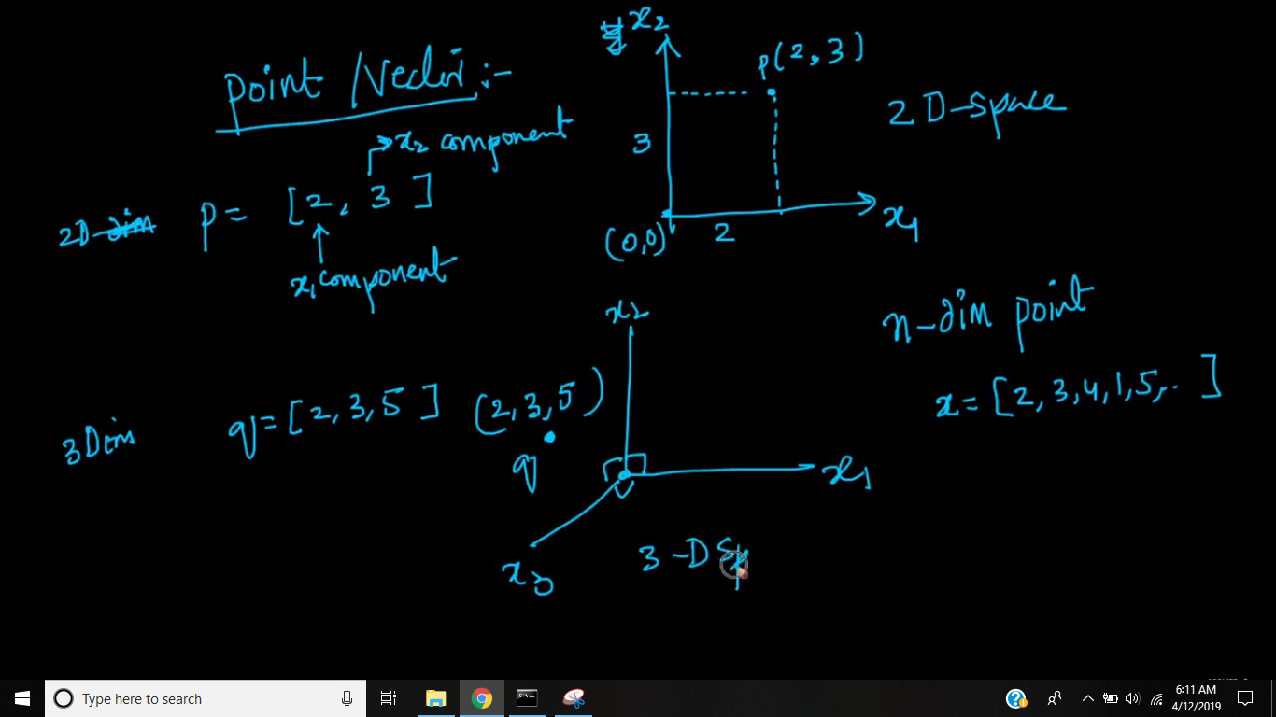

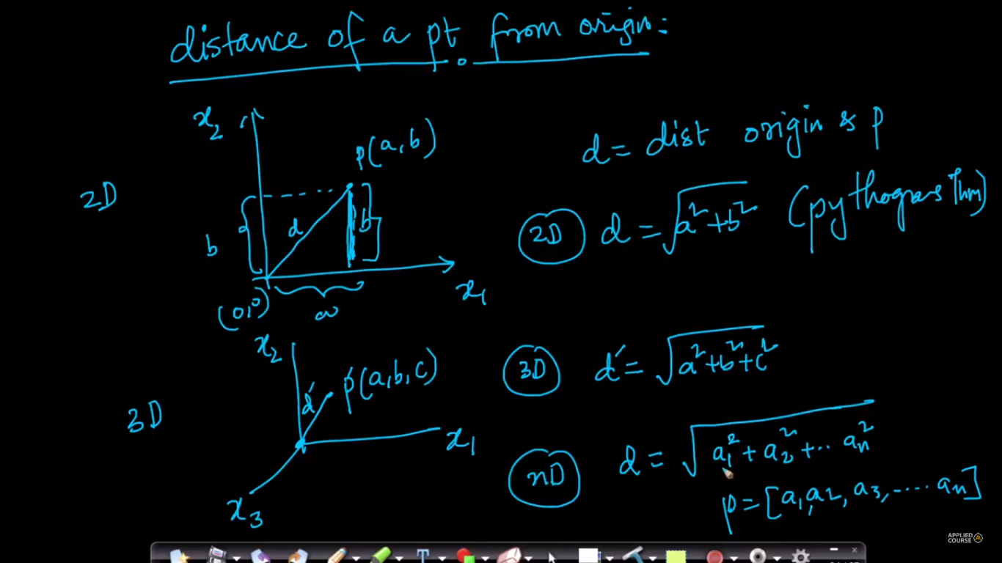

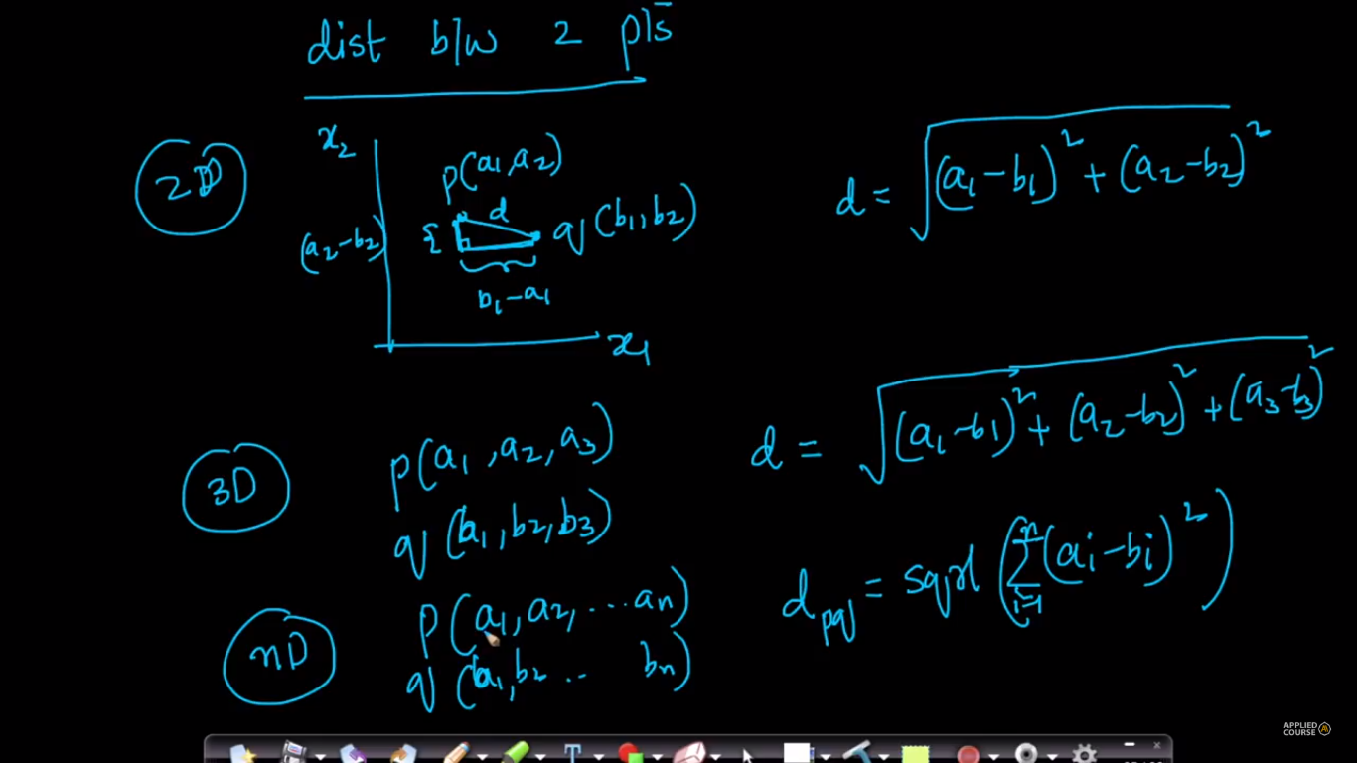

**Row Vector:** Row vector is similar to a vector we seen above and it’s dimensions specified as (1 * n), here

1 -> row

n -> columns

**Column Vector:** Column vector is basically a dataset with 1 feature and 1 or more rows in that dataset and it’s dimension as (n * 1), here

n -> rows

1 -> column/feature

